What is Moodle?
Moodle is an educational platform designed to offer courses and virtual communities services through the Internet. The tool allows us to:
- Present educational material in the form of lessons, works, exercises, questionnaires, etc.
- Provide informational resources such as forums, chats, audio, video, web pages, etc.
- Offer activities where students can interact with each other or with the tutor. As a participant, this platform will let you share and integrate the virtual learning experience using the tools presented bellow.
A brief introduction can be found in the following short video (https://youtu.be/3ORsUGVNxGs):
How to Access Moodle
- You can reach the eLearning site from the QUICK LINKS menu in the university website https://www.aaup.edu, or you may Access Moodle Site directly through the link https://moodle.aaup.edu
- Enter your user name and password ( Same as your Portal’s username and password).
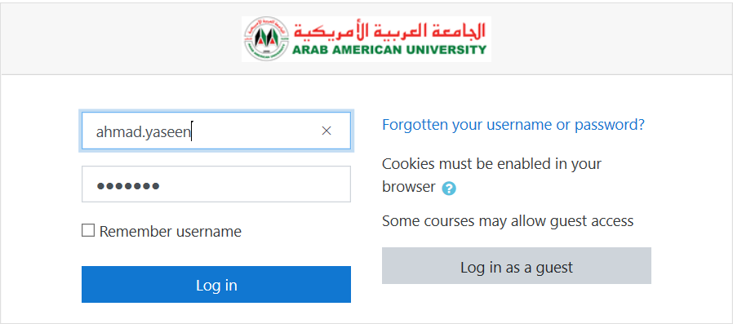
Figure 1: Moodle Login Page

Dashboard:
After logging in to Moodle, you will access your main Dashboard where you can:
- Change the Moodle display language (English or Arabic)
- Explore your current semester courses.
- Explore notifications and messaging services.
- set up your profile and preferences.
We strongly recommend to watch this short video that explains the dashboard features: (https://youtu.be/VApmuVO7sHY?list=PLxcO_MFWQBDdoXpGILaTAj8S6O8-I6nRR)
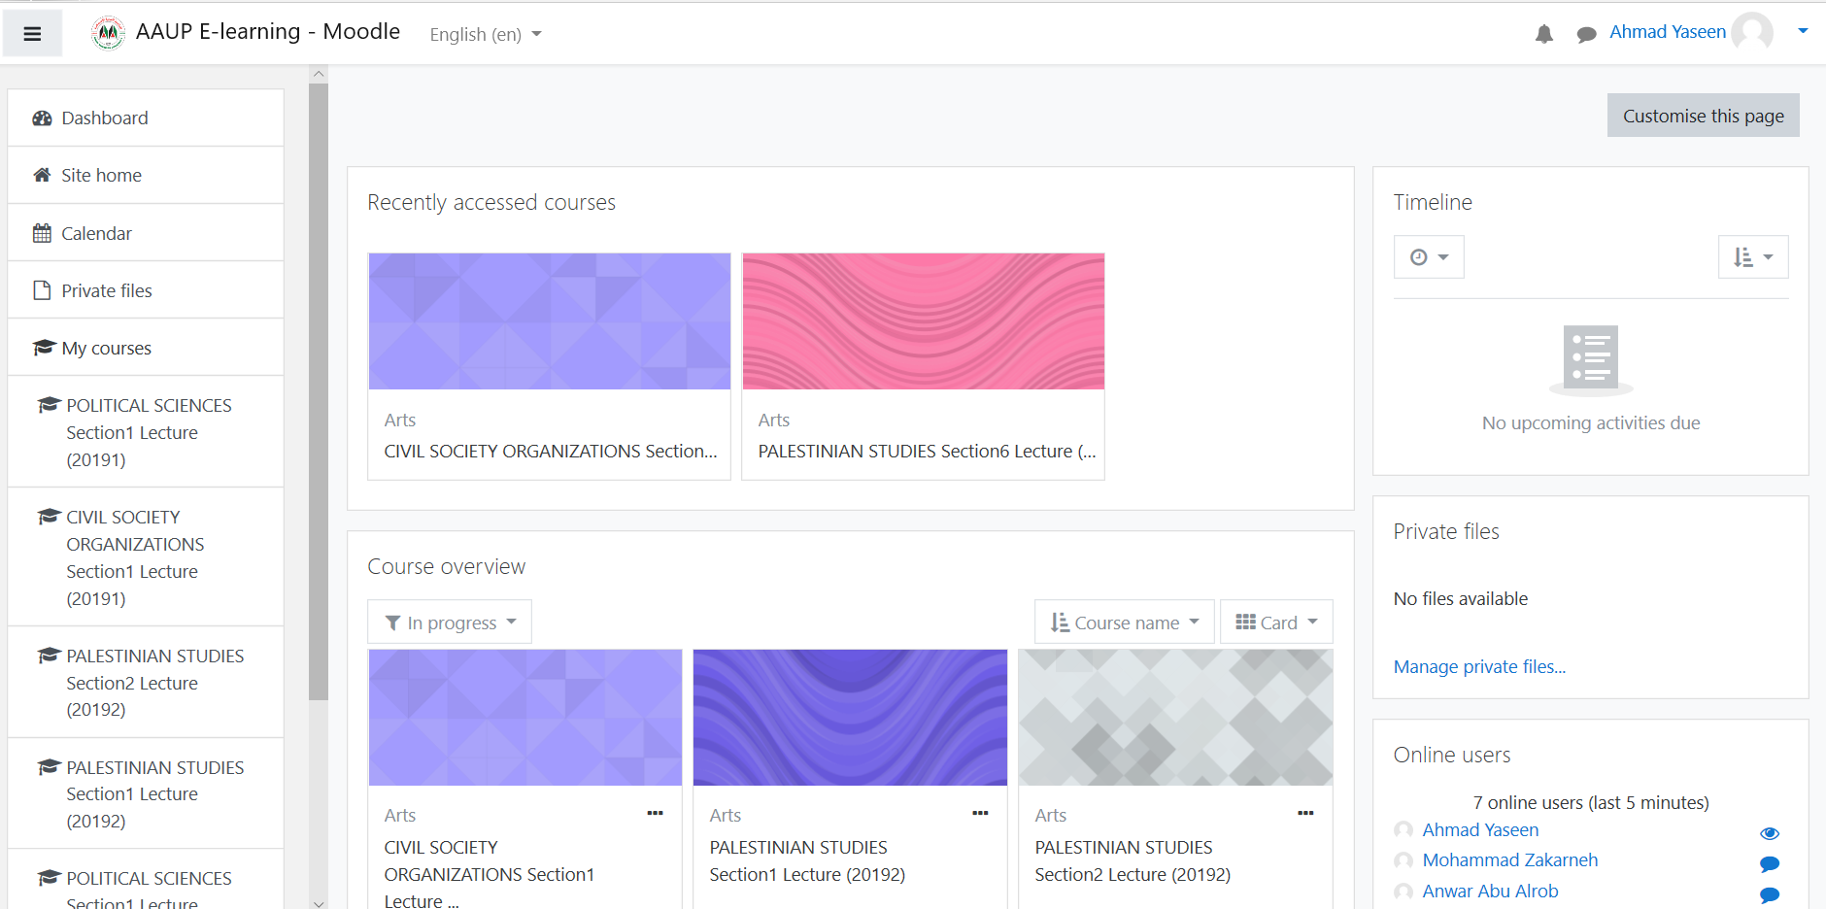
Figure 2: Instructor Dashboard

Course Page:
To access the course page for any of your courses, click on the course name from the list of courses in the dashboard.
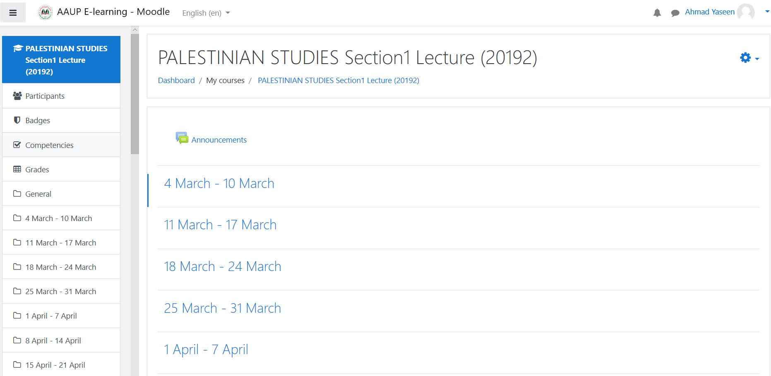
Figure 3: Course Page
For more information on the course page features, refer to the following videos:
Figure 4: Edit Course Sections (https://youtu.be/ZHE8ygJH1wI?list=PLxcO_MFWQBDdoXpGILaTAj8S6O8-I6nRR) | Figure 5: What is a course? (https://youtu.be/O_bPmYfBTro?list=PLxcO_MFWQBDdoXpGILaTAj8S6O8-I6nRR)

The course page includes a set of services to enable the instructor to manage course outline and activities in addition to browse and communicate with course students.
The Participants service in the left side menu opens the list of course students and enable the instructor to send a message, add note or students list (As shown in figure 3).
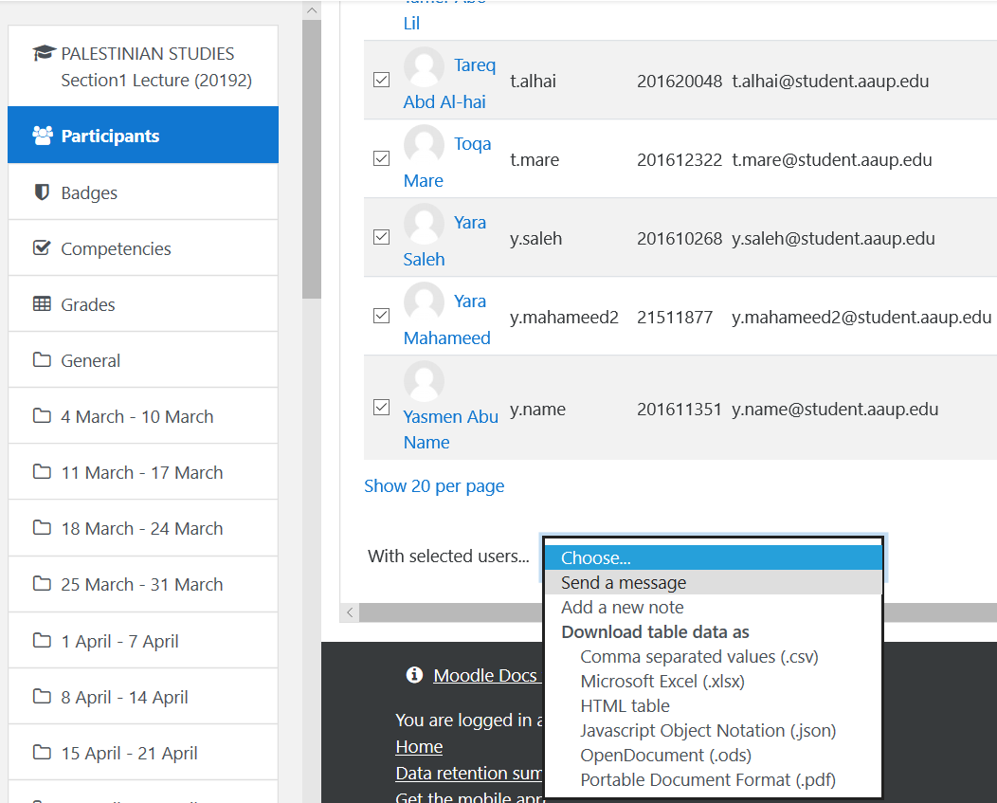
Figure 6: Course Participants
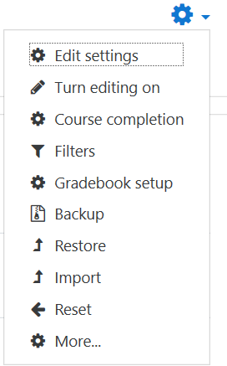
The course page also includes the course plan template divided into 16 weeks according to course syllabus, this categorization will enable the course instructor to add materials and activities on a weekly basis. To make the course plan editable, click on the gear icon on the right side of the page and select “Turn editing on”. This will enable the instructor to:
- edit week titles.
- Add activities and resources by week.
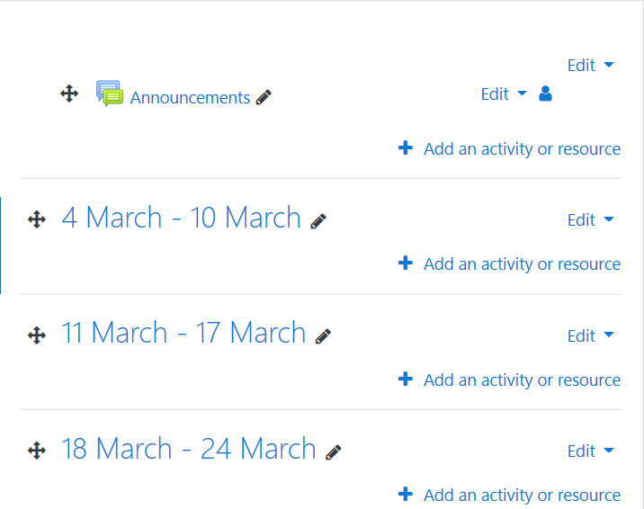

To add an activity or resource, click on “Add an activity or resource” link for a selected week.
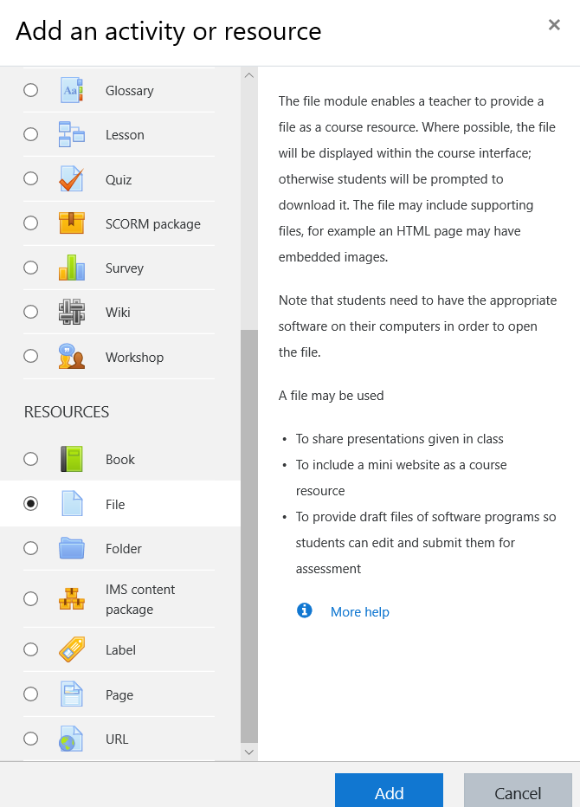
- click on the requested activity or resource to display a short description about it.
- The popular activities and resources are:
- File
- URL
- Assignment
- Chat
- Forum
- Quiz
- Survey
- BigBlueButtonDB ( Online Class).
Watch this video on how to upload a file https://www.youtube.com/watch?v=CMs2JI8s1IY&list=PLxcO_MFWQBDdoXpGILaTAj8S6O8-I6nRR&index=20
We strongly recommend to watch the learning videos about each activity in the Moodle YouTube channel (https://www.youtube.com/playlist?list=PLxcO_MFWQBDdoXpGILaTAj8S6O8-I6nRR)

Moodle Mobile App
You can download the Moodle mobile app for both IOS and Android based smart phones through app store and google play respectively:
IOS: https://itunes.apple.com/app/moodle-mobile/id633359593?mt=8
Android: https://play.google.com/store/apps/details?id=com.moodle.moodlemobile
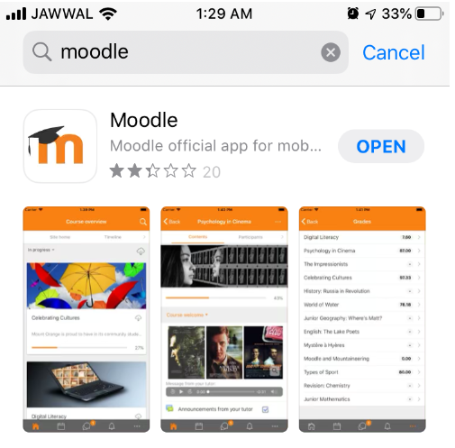
After installing the Moodle app, enter the URL https://moodle.aaup.edu as the Moodle site URL.
Then enter your user name and password.
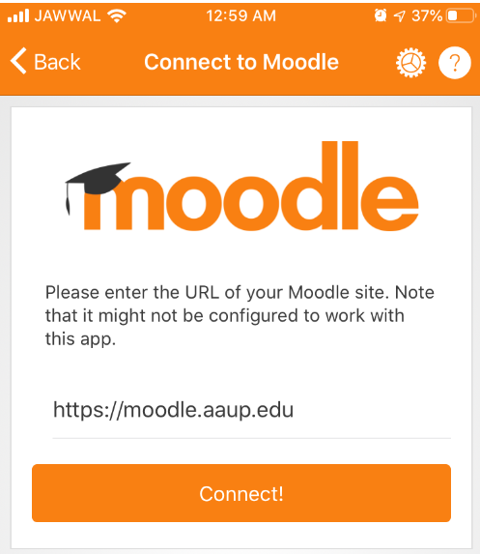 | 